WebstaurantStore Code Screen – Summary and Results

Team,

I executed a low-load, short-duration automated baseline performance test on various “Outlet” product pages under the heading “WebstaurantStore > Scratch and Dent Appliances & Foodservice Equipment”.

Test was run on below set of “Equipment’s” and “Supplies” Outlet items on “webstaurantstore.com” production environment –

* Restaurant Equipment
* Cooking Equipment
* Commercial Ice Equipment and Supplies
* Commercial Ovens
* Beverage Equipment
* Refrigeration Equipment
* Merchandising and Display Refrigeration
* Reach-In Refrigerators and Freezers
* Bar Refrigeration
* Undercounter Refrigerators
* Industrial Supplies
* Storage & Workspace
* Facility & Maintenance
* Business Type
* Hotel Supplies
* Office Products
* Janitorial Supplies
* Janitorial Equipment
* Restroom Supplies
* Trash Cans and Recycling Bins
* Tools: Test was scripted, setup and executed using “apache-jmeter-5.5” with “jre-1.8” on “Windows 11”.
* Assets: https://github.com/architectester/webstaurantstore.git
* Purpose: Execute automated test for 15 minutes to achieve 5 rounds/page/min. and capture “Avg.” and “95th“ percentile response times of each of the outlet pages along with application resources metrics, if available.
* Description: Test execution details –
  + Load : 1 vUser
  + Ramp-Up : 1 sec.
  + Ramp-Down : 1 sec.
  + Duration : 15 mins.
  + Start Time : 03/08/24, 09:44 PM est.
  + End Time : 03/08/24, 09:59 PM est.
  + Environment : Production *(https://www.webstaurantstore.com/outlet.html)*
  + Test Script : JNilak_WebstaurantStore_CodeScreenTask-Performance_20240308_run-1.jmx
  + Test Results : JNilak_WebstaurantStore_CodeScreenTask-Performance_20240308_run-1.jtl
* Observations: Key Findings and Observations –
  + Test was run with 1 Virtual User with a steady load-state of 15 mins and achieved 5-page calls/min.
  + Achieved 75 calls/ product-page with a total of 1,200 page calls in 15 mins.
  + Stable response times across the board during the steady-state for all product pages.
  + No HTTP-500 or HTTP-Gateway timeout errors during the test.
  + The 1st highest Avg. of 825.41 ms. response time was observed for “../outlet.html” home page.
  + The 2nd highest Avg. of 564.32 ms. response time was observed for “Cooking Equipment” page.
  + The 3rd highest Avg. of 564.32 ms. response time was observed for “Hotel Supplies” page.
  + Web, App, DB and Network monitoring data will be captured & shared later.
* Recommendations: Key Takeaways and Recommendations –
  + Execute repeatable tests on every new build/release and compare for trend analysis.
  + Execute tests from different sources (cloud, intranet, internet) & regions (east, mid-west, west).
  + Execute more rounds with incremental load increase and compare results for any system degradation.
  + Execute longevity test with 6+ hours at a steady-state to uncover any memory leaks.
  + Monitor Web servers, Application servers and Database servers live for any anomalies.
  + Setup LAN to WAN monitoring, using Network Monitoring Agents to measure network metrics like latency, jitter, packet loss and such.
* Summary: Response Times Statistics –

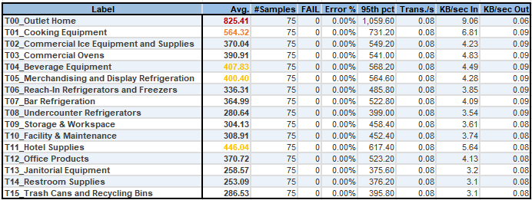

* Summary: Response Times Over Time –

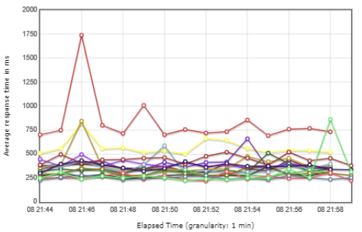

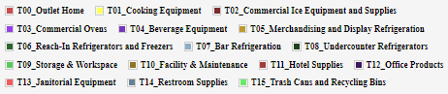

* Graph: Hits/Sec –

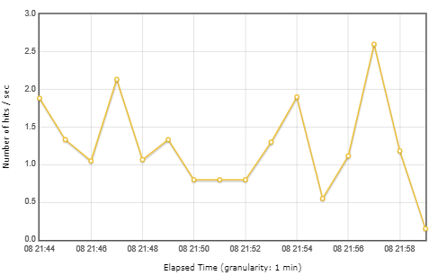

* Graph: Bytes Throughput Over Time –

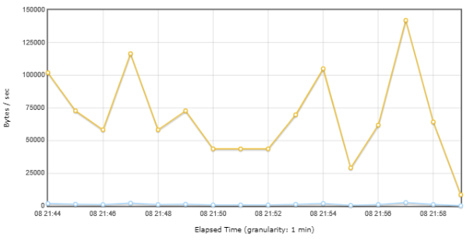

* Graph: Requests Summary (PASS/FAIL) –

